## **Project Work:**

## The goal of this project is to analyze an existing digital product (website, mobile app, or desktop application) using HCI principles from Alan Dix’s book. Students will identify design flaws, suggest improvements, and create a redesigned prototype using Figma.

## 

## **Project Report Sample Template**

**Course:** CO2214**:** Practical work on CO2224  
**Group Number/Name:** Group - 02  
**Student IDs:** EUSL/TC/IS/2021/COM/79

EUSL/TC/IS/2021/COM/52

EUSL/TC/IS/2021/COM/100

EUSL/TC/IS/2021/COM/11

EUSL/TC/IS/2021/COM/66

EUSL/TC/IS/2021/COM/40

## **1. Project Overview**

* **Project Title:** *Virtual Learning Environment- LMS*
* **Project Type:** *Website*
* **Domain:** *Education*
* **Brief Description:** *This project focuses on enhancing the usability and organization of a Learning Management System (LMS) by addressing key design flaws. The dashboard will be improved to display pinned current semester courses instead of just recently accessed ones, allowing users to navigate more efficiently. A "Keep me logged in" option will be added to reduce session timeout interruptions. Additionally, separate tabs for exam results and timetables will be introduced, making important information easier to access. Along with these improvements, the UI will be refined with better color schemes and minimal design changes for a more user-friendly experience. The redesigned prototype will be developed using Figma, ensuring a more intuitive and efficient LMS.*
* **The user***: Students and Lecturers*

**Data Collection and Analysis**

1. More user friendly interface and calendar with deadlines and lectures

Reason : It is easy to access if it is on top of the page . While we access the course we can check the calendar easily.

1. Course names should be in the same name format, it will help to find the courses easily. Some lecturers added the course name in a different format, that of courses shown with other semester courses. Dynamic UI designs are expected.

Reason : While accessing the lms the user should not confused with the names so all course names should be in a structured way that’s why we suggesting all names same format.

1. Change the design of the home page

Reason : All elements in the home page are collapsed so it is difficult to differentiate all the things so it should be arranged properly.

**2. Identifying Design Flaws & Gaps**

* **Evaluation Criteria:** Visibility, Constraints, Consistency , feedback
* **Usability Issues Identified:**

1. ***Limited Dashboard Functionality***

The current LMS dashboard only displays recently accessed courses, making it difficult for users to access their ongoing semester courses quickly.

Users have to manually search for their current semester courses every time they log in.

1. ***Session Timeout Issue***

The LMS frequently logs out users due to session expiration, which disrupts workflow.There is no option to stay logged in, forcing users to repeatedly enter credentials.

1. ***Unorganized Exam Results and Timetable Access***

Exam results and timetables are uploaded in the announcements section, making them difficult to locate.

Users have to scroll through multiple announcements to find relevant information.

1. ***Lack of Personalization and Navigation Efficiency***

Users cannot pin or prioritize courses based on their semester, leading to inefficient navigation.

The UI lacks customization options to tailor the experience to individual user needs.

1. ***Inconsistent UI Design and Color Scheme***

The LMS interface lacks a well-structured and visually appealing color scheme, making it less engaging.

Minor UI inconsistencies affect the overall user experience and readability.

* **User Experience Problems:** *(Identify UX-related issues such as navigation complexity, readability, accessibility, etc.)*
* **Screenshots & Examples:**
* ***Limited Dashboard Functionality***

*Figure 1*

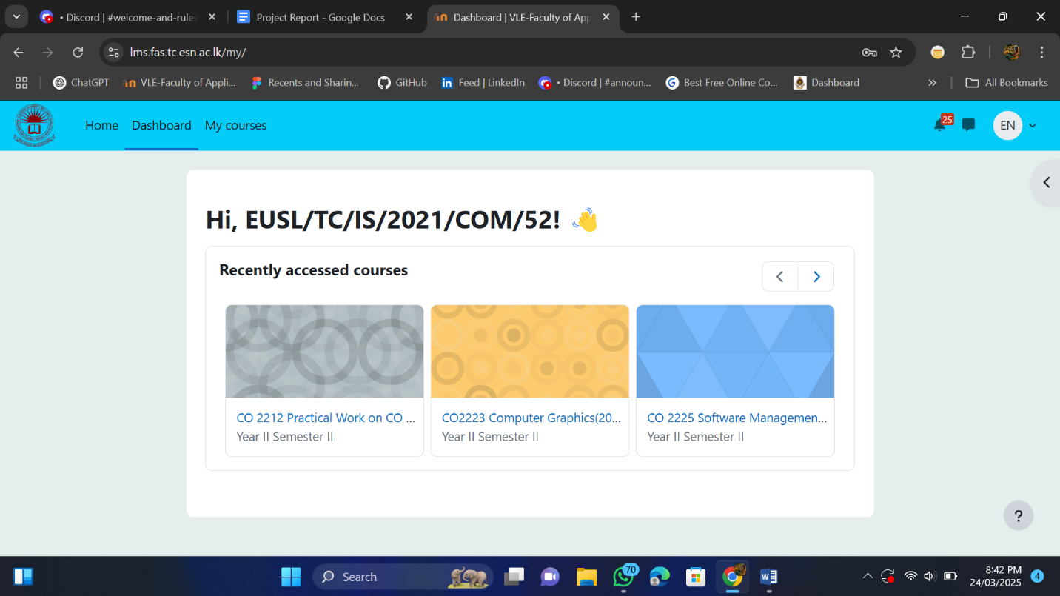

*Figure 1.1*

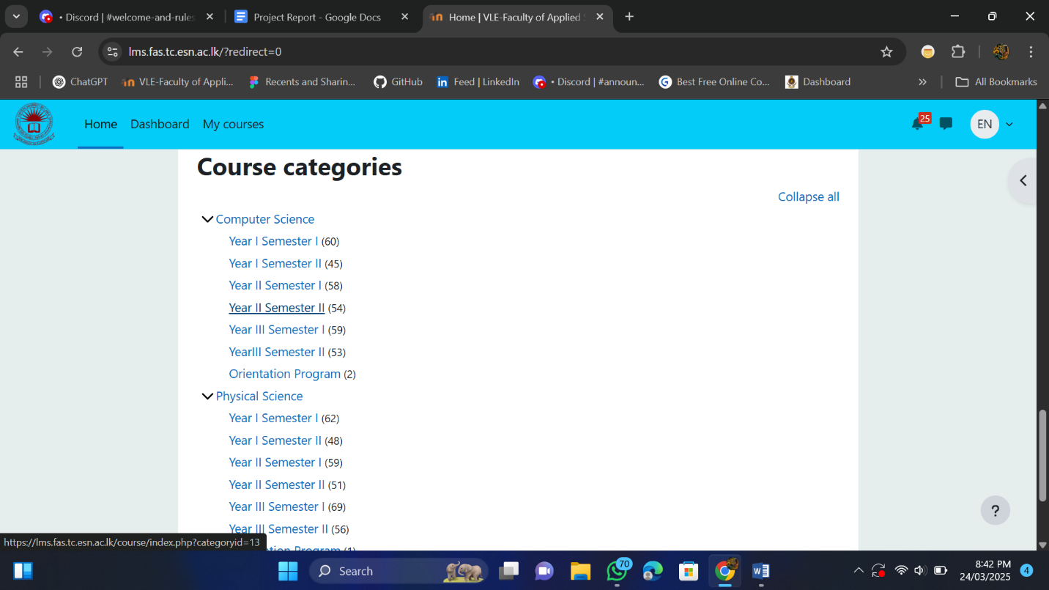

*Figure 1.2*

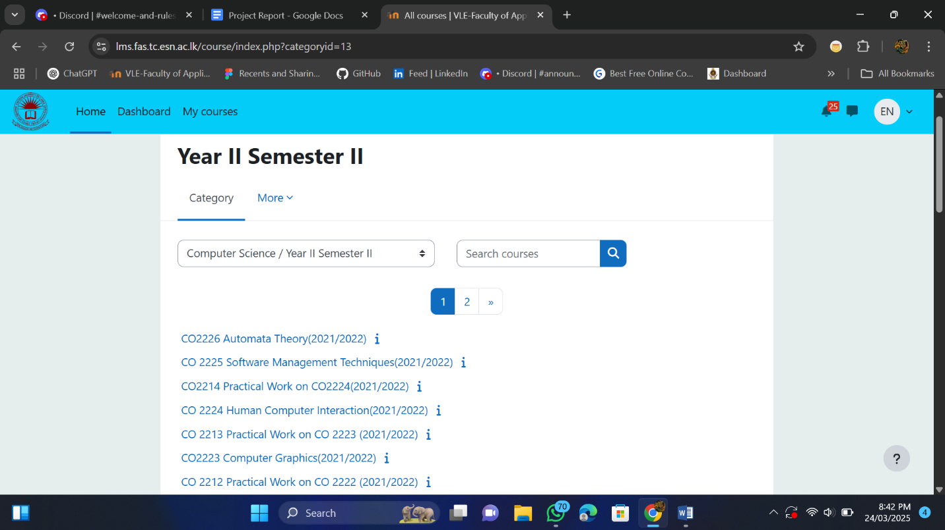

* ***Session Timeout Issue***

*Figure 2*

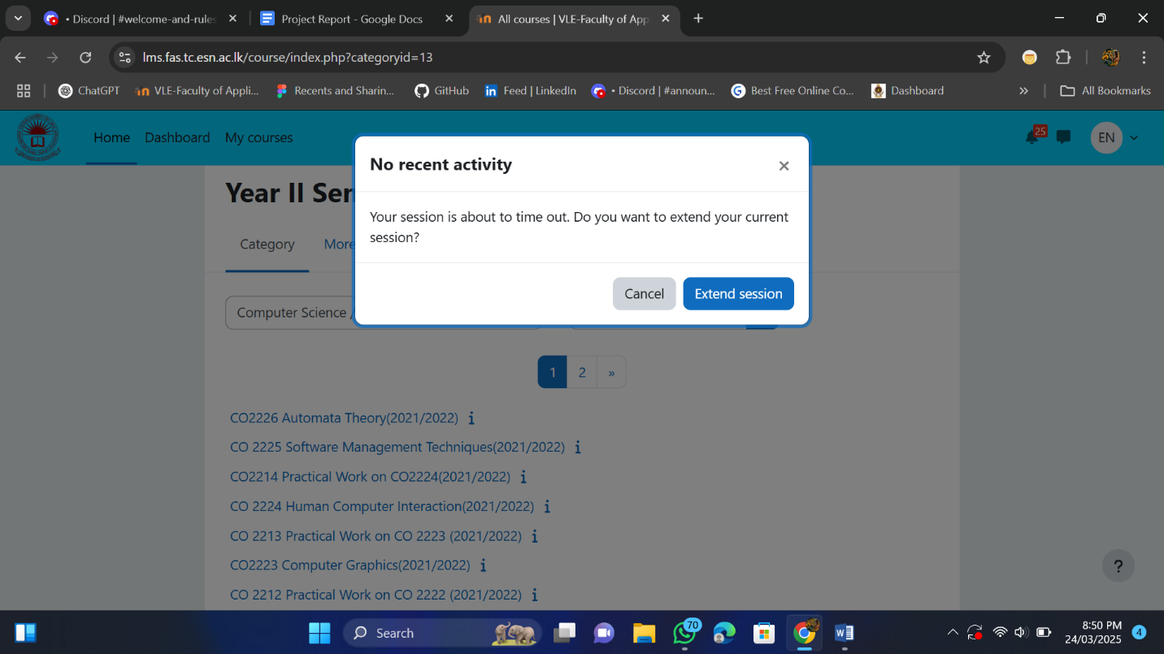

* ***Unorganized Exam Results and Timetable Access***

*Figure 3*

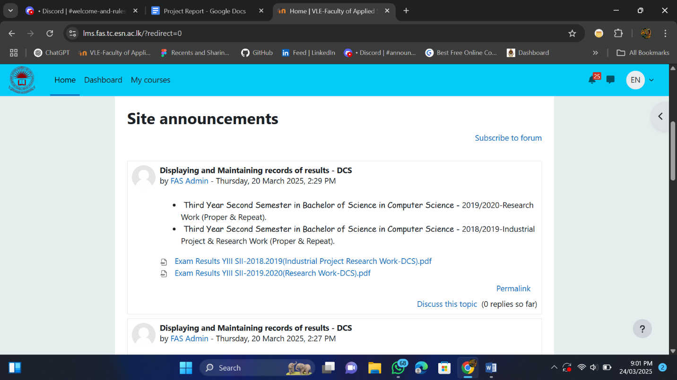

*Figure 3.1*

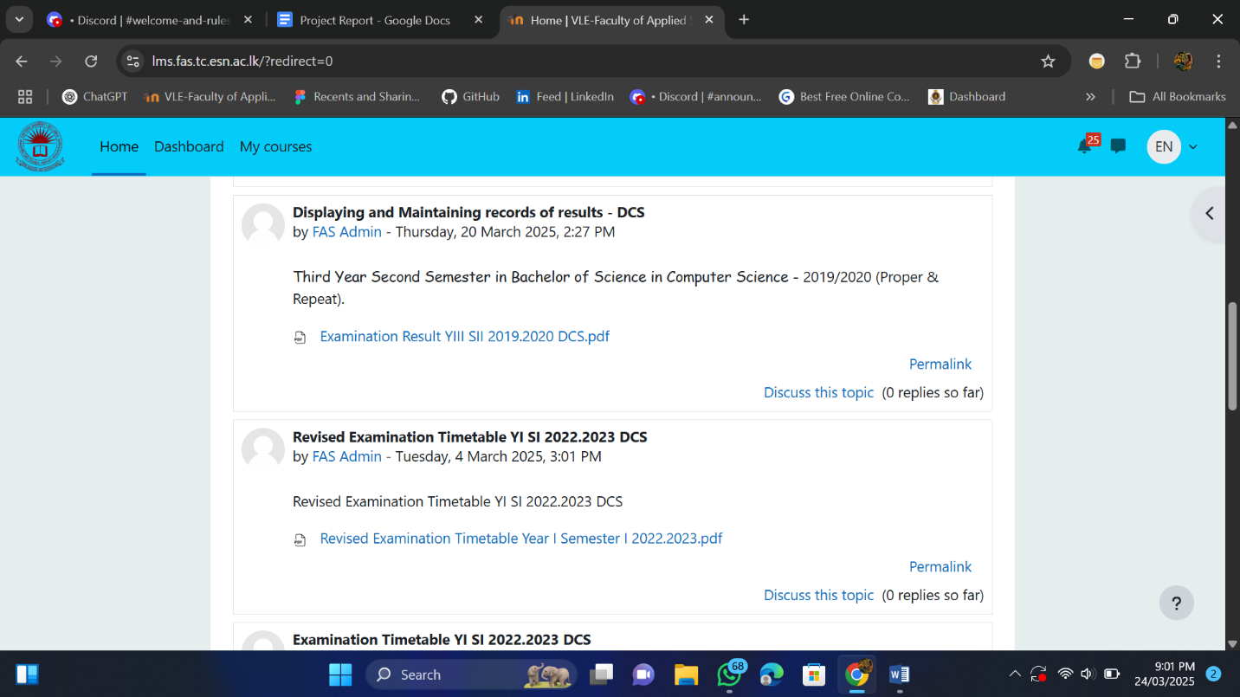

*Figure 3.2*

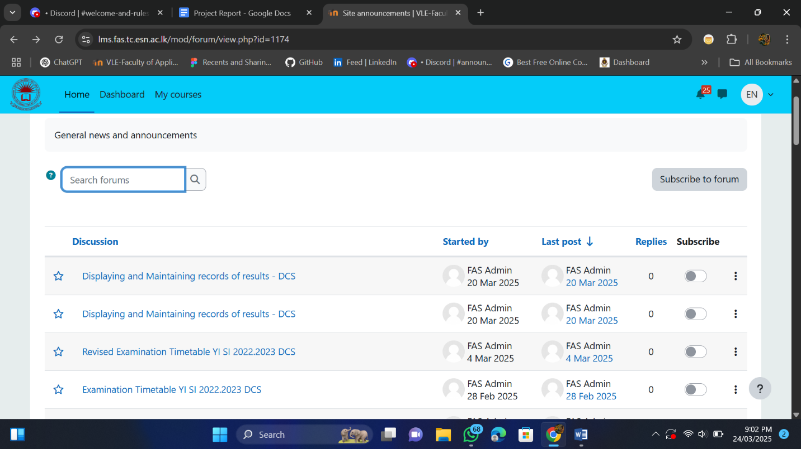

* ***Lack of Personalization and Navigation Efficiency***

*Figure 4*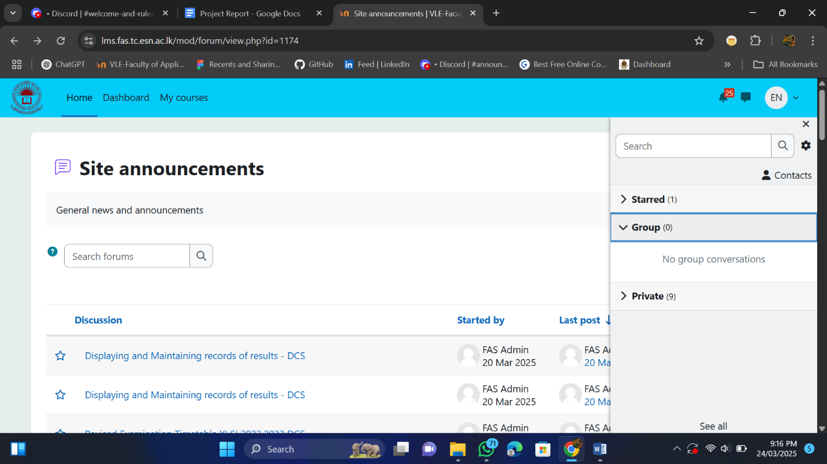

*Figure 4.1*

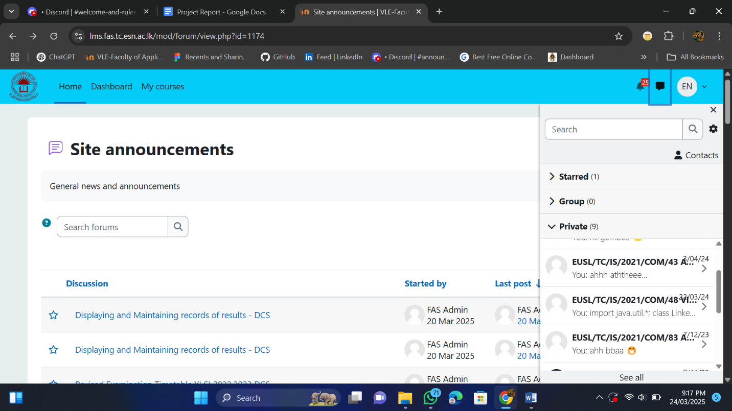

* ***Inconsistent UI Design and Color Scheme***

*Figure 5*

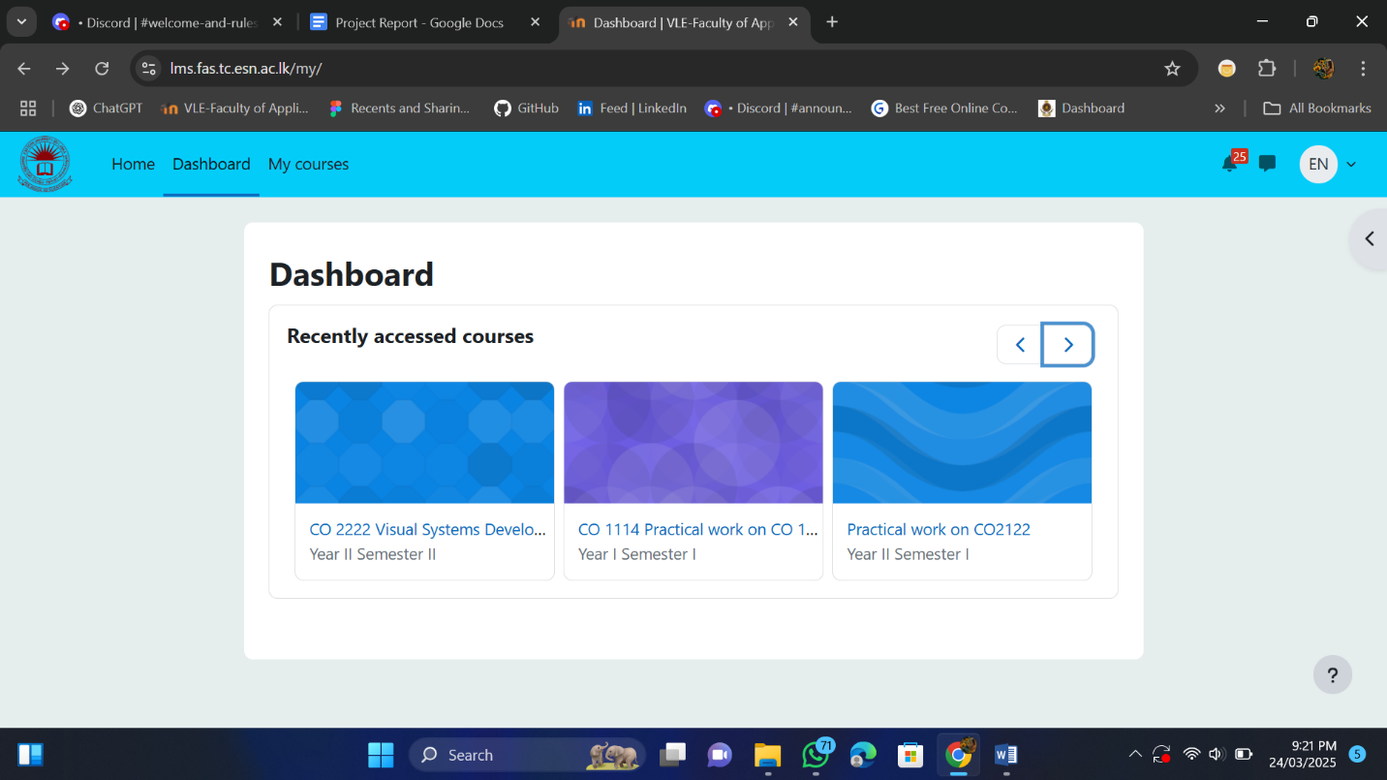

*Figure 5.1*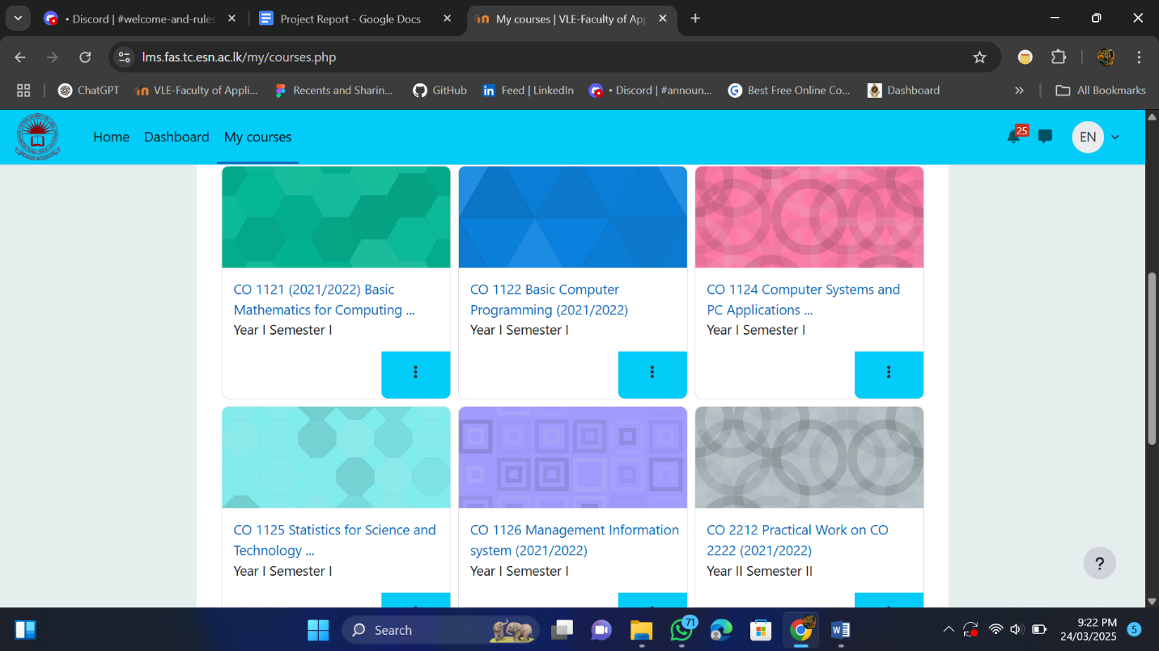

* ***User feedbacks:*** *from minimum 3-5 users*

## ***3. HCI-Based Design Improvement Suggestions***

* ***Proposed Improvements:***

1. ***Improved Dashboard Navigation*** Display pinned or ongoing semester courses at the top of the dashboard. This reduces cognitive load and helps users locate important courses without unnecessary search—supporting the HCI principle of visibility.
2. ***“Keep Me Logged In” Option*** Add a checkbox on the login screen to allow users to stay logged in across sessions. This improves workflow efficiency and supports the HCI principle of flexibility and user control.
3. ***Dedicated Tabs for Exam Results and Timetables*** Introduce a side navigation or top tab labeled “Exam Results” and “Timetable” for quick access. This avoids clutter and supports information structure and consistency.
4. ***Unified Course Naming Format*** Enforce a naming convention for course titles to maintain interface consistency and enhance information retrieval.
5. ***Clear Visual Hierarchy & Layout*** Rearrange the homepage to segment content clearly (e.g., announcements, deadlines, upcoming classes). This makes important elements stand out, fulfilling the HCI principle of affordance and clarity.

* ***Recommended Usability Fixes:***

1. ***Consistent Button Placement & Labels*** *Standardize the position and labels of common actions (e.g., “View”, “Submit”, “Edit”) across modules.*
2. ***Inline Feedback for Actions*** *Show immediate confirmation messages after submission or updates (e.g., “Course added to pin”).*
3. ***Use of Icons with Text*** *Support buttons with simple icons (e.g., 📅 for calendar) to enhance recognition over recall.*

* ***Accessibility Improvements:***

1. ***Color Contrast Compliance*** *Use WCAG 2.1 guidelines to ensure high contrast between background and text (minimum 4.5:1).*
2. ***Resizable Text Support*** *Allow users to zoom or change text size without breaking the layout.*
3. ***Keyboard Navigation Support*** *Ensure all interactive elements are accessible using keyboard shortcuts or tab navigation.*

* ***Interaction Improvements:***

1. ***Dropdowns and Filters for Course List*** *Let users filter courses by semester, department, or active/inactive status.*
2. ***Calendar Integration with Reminders*** *Embed a calendar view with deadlines, exams, and classes—clickable for more info. Supports better task management.*
3. ***Enhanced Search Function*** *Include real-time search suggestions for faster access to course materials or announcements.*

* ***Anything else?***

*<<These are not limited, You can add more.>>*

## ***4. Redesigned Prototype in Figma***

* ***Overview of the New Design:***

*1.The new design is focused on several improvements for the student side. We extended the session timeout to over 30 minutes, allowing students to stay logged in longer (optional – they can extend it only if they wish).*

*2. We added the calendar to the menu bar, making it easier for students to access it without interrupting their course view. Previously, the calendar was located inside their profile.*

*3. Previously, we displayed recently accessed courses on the dashboard. As an alternative, we proposed pinning the current semester's courses to the dashboard, making it easier to access them. Other courses can still be accessed from the homepage or the courses page.*

* ***Wireframes & Mockups:***

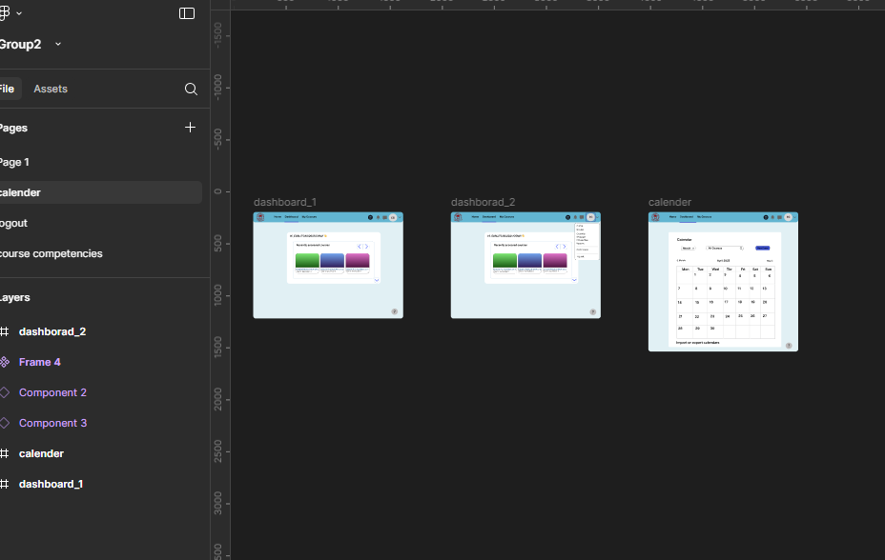

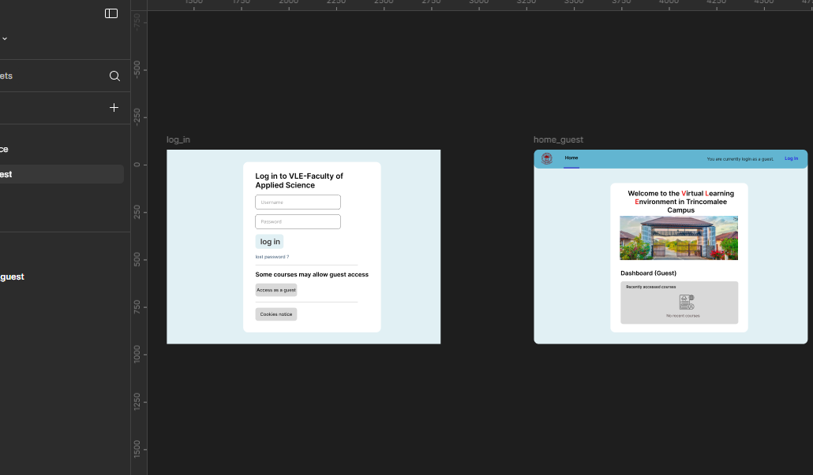

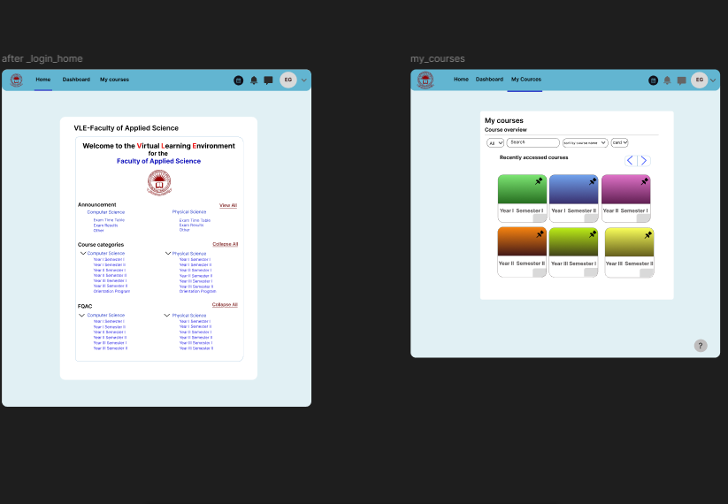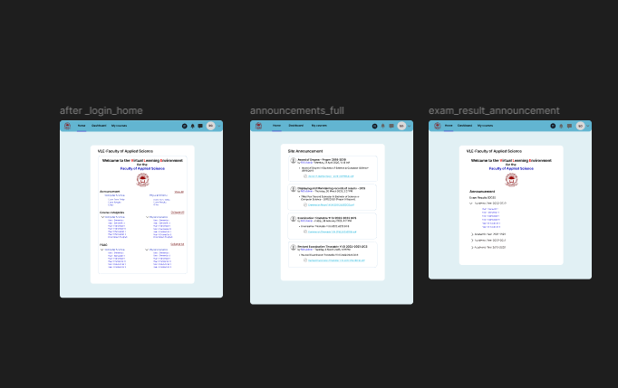

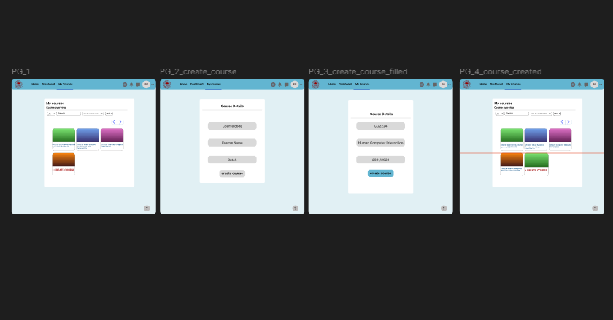

* ***User Flow Diagram:*** *(Illustrate how users interact with the improved version)*
* ***Prototyping Features Used in Figma:*** *we use simple and consistent animations and instant prototypes between pages.*

## ***5. Evaluation & Testing***

* ***Usability Testing Plan:*** *we can test among students and get feedback how much the changes are helpful to them.*
* ***Expected Outcomes:*** *it will reduce the confusion of accessing courses and announcements. At the same time they can use the calender efficiently.*
* ***Limitations & Future Improvements:*** *The designing part is only focused on the student side only. In future we can consider about lecturer side and admin side.*

## ***6. Conclusion***

* ***Final Thoughts on the Redesign:*** *the resign of calender, announcement and dashboard are more helpful to the students which can simplify their searches, at the same time the consistent naming of the courses will reduce the confusions.*
* ***How HCI Theory Helped:*** *the designing principles and other HCI theories helped a lot to design the page. For consistent coloring. Tabs , natural language usage..*
* ***Lessons Learned:*** *we learned how to design the ui user friendly, apart from the colorful designing and our creativity , we understood the real issues faced by user while accessing the pages. And learned how to deliver a efficient UI.*

### 

### ***7. References if used any***

***8. Team Member Contribution***

| ***Team Member*** | ***Contributions*** |
| --- | --- |
| EUSL/TC/IS/2021/COM/11 | Designing, prototyping |
| EUSL/TC/IS/2021/COM/52 | Project Report, Designing |
| EUSL/TC/IS/2021/COM/40 | Designing |
| EUSL/TC/IS/2021/COM/66 | Designing |
| EUSL/TC/IS/2021/COM/79 | Project report , feedback form, designing |
| EUSL/TC/IS/2021/COM/100 | Project report, designing |

For more details : [Team members Contributions](https://docs.google.com/spreadsheets/d/12ZyV37LcGygcqjKSnmL1nI-GPfdO59WJA_cqU8QYbjA/edit?usp=sharing)

### ***Appendices (If applicable)***

* ***User Feedback Surveys*** *:* [*https://forms.gle/oVS4FNLqUBRYs8py5*](https://forms.gle/oVS4FNLqUBRYs8py5)
* ***Survey response*** [*LMS Feedback Form (User Experience Evaluation) (மறுமொழிகள்)*](https://docs.google.com/spreadsheets/d/1fkjrRU4twwOR-kSb5AiFqMjC7HhUaDzgrkOoYIXzjbI/edit?usp=sharing)
* ***Additional Design Mockups*** *(Alternative design approaches explored in Figma)*